**It's the Camel Not the Burro**

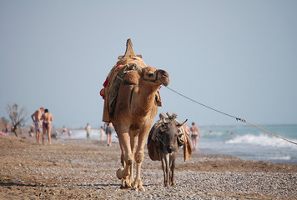

**It's the camel not the burro**

**They take the burro, the camel walks away**

**The meaning is obscured, but true**

**Israel, Kerry, Obama, and Trump take their turn**

**This sets the stage**

**He takes it to a new location**

**Where it can do the most good**

**One leader is killed, the other get's his way**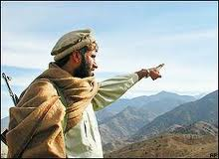

**He looks closer on the few**

**His name is Isis, his view is on one thing**

**He pays much for it**

**It's on the Camel**

**No one knows it's there**

**Then when the time is right**

**America finds their demise**

**America blames the wrong one**

**Then Retribution**

**No one on our side can believe the Americans are so dumb**

**They are either dead or greatly saddened**

**They are placed in the Sun**

**There is no forgiveness**

**The New World is born**

